Wizard of Oz Auditions form #_____
Name: ____________________________________ grade: ___________teacher: ____________
Home mailing address: __________________________________________________________
Contacts: phone #: ______________________ email: _________________________________
Parent/guardian name: _________________________________________________________
Parent/guardian info: (only if different) _____________________________________________
Parent #: ___________________ Parent: email: _________________________________
Height: ____________ hair color: ______________ eye color: _______________
Previous Acting / Dancing / Singing/ Theater Experience: (please list up to 5 shows and roles)
Show: role: ______________________________
______________________________________________________________________________________________________________________________________________________________________________________________________________________________________________________________________________________________________________________________________________________________________________________________________
Conflicts: (please list all conflicts: rehearsal are Tuesday: 6:00-8:30, Thursday: 3:15-4:45.
Conflicts won’t necessarily preclude you from being cast in this show)
________________________________________________________________________________________________________________________________________________________________________________________________________________________________________________________________________________________________________________________
Just a few more things:
In the event you do not get a part, would you still be interested in remaining in involved with the production in any of the following areas? (circle all that apply)

Stage crew set construction lights ticket sales ushering
Desired roles:
1._____________________
_______ I am interested in the parts listed, but will accept 2. _____________________
ANY part including chorus. 3. ______________________
______ I am only interested in a chorus part. 4. ______________________
Scene break down:
Act 1
Scene 1 - Kanas farm
Scene 2 -Kansas Farm
Scene 3 –Kansas Farm
Scene 4 -Gypsy Caravan
Scene 5 – The Twister
Scene 6 – Munchkin Land
Scene 7 Munchkin Land
Scene 8 Scarecrow Field
Scene 9 -Tinman forest
Scene 10 - Forest
Scene 11 -Forest
Scene 12 - Forest
Scene 13 -Poppies

Act 2:
Scene 1: Gates of Emerald City
Scene 2: Emerald City
Scene 3: Wizard Chamber
Scene 4: Gates of the Emerald City
Scene 5: Witch’s castle
Scene 6: Haunted Forest
Scene 7: Flying Monkeys
Scene 8: Witch Castle
Scene 9: Witch Castle
Scene 10: Witch Chamber
Scene 11: Witch Chamber
Scene 12/13: Balloon – Emerald City
Scene 14: Kansas Farm

All Cast Scenes:
Act 1: Scene: 5-7
Act 2: Scenes: 2, 12/13

Characters:
Dorothy
Tinman
Scarecrow
Lion
Guard
Aunt Emily / Glinda
Uncle Henry
Huck
Hickory
Zeke
Miss Gultch / Wicked Witch
Professor Marvel / Wizard of Oz
Winkies
Flying Monkey
Munchkins
Poppies
People of Oz
Costumes by Character:
Dorothy – blue gingham dress
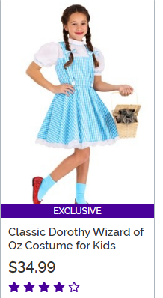

Lion – Scarecrow

Aunt Em 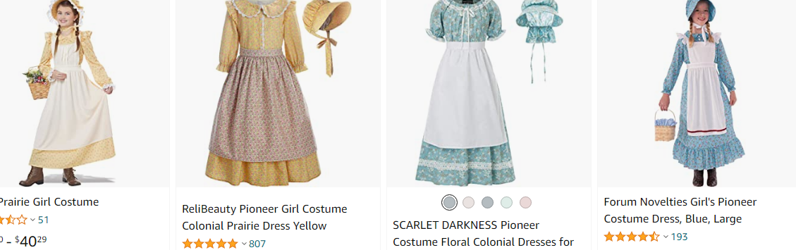

Tinman
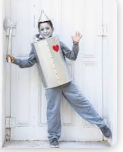

Munchkins – bright colored shirts and black pants/shoes/socks

-Lullaby League – pink ballerina outfits Tough Kids - Shorts – blue shirts
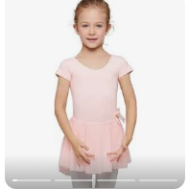-

Miss Glutch / Witch – black witch costume
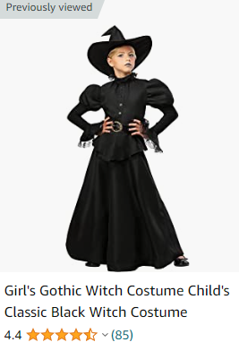

Winkies -
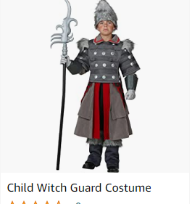

Flying Monkeys

Uncle Henry / Huck/ Hickory / Zeke (earth tones / browns)
Overalls/ flannel shirt,
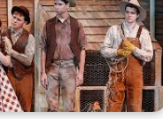

Emerald City People – Green shirts and black pants/shoes/socks
(any Laker School shirt turned inside out will work great)

Rehearsal Schedule:
Thursday, February 23, 2023: 3:15-4:15ish
Auditions – cancelled due to weather

Monday, February 27, 2023: 6:00-8:15
Parent meeting, auditions scripts / songs
Thursday, March 2. 2023: 3:20-4:30pm – Band room
Munchkin Land song / Merry old Land of Oz song

Monday, March 6– 6:00-8:30pm
6:00-7:15 – Act 1: Scene 6, 7
7:15-8:10 – Act 1: Scene 8, 9, 10, 11
8:10-8:30 – Songs: Dorothy, Tinman, Scarecrow, Lion, Glinda
Thursday, March 9, 3:20-4:30pm
Act 1 -Scene 1, 2, 3, 4, 5
Act 2- Scene 14

Monday, March 13– 6:00-8:30pm
6:00-7:20: Act 2: Scene:1, 2
7:20-8:10: Act 2 Scene 3, 11, 12, 13(no citizens of Oz for this time)
8:10-8:30: Songs: Dorothy, Tinman, Scarecrow, Lion, Glinda
Thursday, March 16- 3:20-4:30pm
no rehearsal: Choir / Band Festival

Monday, March 20– 6:00-8:30pm
6:00-7:15: Act 1 Scene 6, 7, Act 2 Scene 1, 2
7:15-8:15: Act 1 Scene: 8, 9, 10, 11, 12, 13
8:15-8:30: Songs: Dorothy, Tinman, Scarecrow, Lion, Glinda
Thursday, March 23– 3:20-4:30pm
Act 2: Scene: 4, 5, 6/7, 8, 9 ,10

March 27-31
-spring break-

Monday, April 3 – 6:00-8:30pm
6:00-7:00 – Act 1: Scene 5, 6, 7, Act 2: Scene 1, 2
7:00-8:00 – Act 1: Scene 1, 2, 3, 4, 12, 13
8:00-8:30 – Songs: Songs: Dorothy, Tinman, Scarecrow, Lion, Glinda
Thursday, April 6 – 3:20-4:30pm
Run Act 2 – off book!

Monday, April 10 –– 6:00-8:30pm off book
Run entire show – off book!
Thursday, April 13 - 3:20-4:30pm
Run all songs on stage with movement

Monday, April 17, 2023– 6:00-8:30pm
Run entire show with songs/shoes/costumes/
Thursday, April 20 - 3:20-4:30pm
Run Act 2

Show-week!

Monday, April 24: 6:00-8:30
Dress Rehearsal run
Tickets on sale
Tuesday, April 25, 2023 6:00-8:30
Dress Rehearsal run
Tickets on sale
Wednesday, April 26
Performance during the day for school
Thursday, April 27
Performance during the day for school
Friday, April 28
Call: 6:00 Performance: 7:00
Saturday, April 29
Dinner 5:00pm, Performance 7:00pm
Sunday, April 30
Call 1:00pm Performance: 2:00

Extra items:
-Performance and Dress rehearsal parent helpers:
For each performance, there needs to be 5 helpers backstage each performance and dress rehearsal and 4 helpers for the performance nights from refreshments. A helper is a parent, guardian, uncle, aunt, grandparent or cousin of a student in the show. You can only sign up for 1 slot. If your child is in the cast, there is a slot for you to sign up for helping.

-Set construction: We will be working on the sets throughout the process of the show on Tuesday evening and Thursday afternoon rehearsals. Due to Dance Recitals and Band Festival/ Rehearsals, sets cannot be stationary. If you can paint, hot glue or think creatively, we need you! First night we will be working on sets will be Monday, March 20, 2023.

-Tickets:
The cost of the show is $6.00 for adults and $4.00 for students (DK-12). Tickets will be sold at the door. Advance tickets for each show will be sold starting on Monday, April 24, 2023 at dress rehearsals.

-Official name list:
Please be sure to check the spelling of names for the program and t-shirt tonight: (March 6, 2023) before leaving the meeting

Google Classroom:
For this year’s production, I will be able to post items to the Lakerfinearts.weebly.com site and to the student directly on a Classroom format. All information will be posted here as well.
The code for the class room is: dpoz37i
Each cast member that is able need to log into this with their school email.

Costumes: Each student provides their own costume. For those with Winkies and Monkeys, please see Dr. Corrion.
Bio form:
Must be turned in by March 24, 2023
Name: ___________________________________________________
Grade: __________________
2 interesting facts: (example: I have a cat named Kat. I have taken dance lessons. I have been in Peter Pan, etc.)
1)__________________________________________________________________________________________________
2) ______________________________________________________________________________________________________

T-shirt order form:
We will be ordering Show t-shirts. The front will be the Show Logo and the back will list all the characters and names from the show. They will be an aqua/blue/green in color with lettering. All shirts are $10.00 each. If you are interested please return the form my March 24, 2023 with payment.

Name: _________________________________
Size: YS YM YL S M L XL XXL XXXL($3 additional charge)

Name: _________________________________
Size: YS YM YL S M L XL XXL XXXL($3 additional charge)

Name: _________________________________
Size: YS YM YL S M L XL XXL XXXL($3 additional charge)

Name: _________________________________
Size: YS YM YL S M L XL XXL XXXL($3 additional charge)

Total # of shirts: ________ x $10.00 each: Grand total: ___________
Type of payment: Cash Check (made out to Laker Schools) # _______

DVD order form:
Due to copyright laws, we have special license to have a professional recording for educational purposes. Quad N Productions will be at a performance to film the show. Only 1 DVD per performer is allowed. There can be no other recording of the show due to copyright and licensing for the show. The cost of the DVD is $15.00.
If interested in a copy please have form and payment in by March 24, 2023.

Name: _____________________________________
Character name: ___________________________
# of DVDs: _________
Payment: Cash Check (make payable to Laker Schools) # ______

Total: $15.00
Due by: March 22, 2022

Cast Dinner:
We will be serving dinner to the cast prior to the show on Saturday, April 29, 2023. We are in need of helpers to help set up, bring desserts or side dishes and clean up. Please fill out following as to what area you will be helping in. Kid friendly work the best. Cast families is welcome. Subs will be provided.
Items needed:
Chips
Cookies
Plates (veggies / meat & cheese)
Bottles of water (no juice or pop)
Napkins

There will be a sign up sheet on Monday, April 24, 2023 for you to fill out the needed items for the dinner. Your help is very a key element in making this show a success.

Wizard of Oz Cast
Parent/guardian sign-up
Dress Rehearsal: Monday, April 24, 2023
Performance helpers:
- __________________________
- __________________________
- __________________________
- __________________________
- __________________________

Dress Rehearsal: Tuesday, April 25, 2022
- _________________________
- _________________________
- _________________________
- _________________________

School day performance: (JH / Rural Schools / Cross / St.John’s):
Wednesday, April 26, 2022: 1:00pm-2:45pm (1:30 start time)
- __________________________
- __________________________
- __________________________
- __________________________
10)__________________________

School day performance (Elementary)
Thursday, April 27, 2022: 1:00pm-2:45pm (1:30start time)
- _________________________
- _________________________
- _________________________
- _________________________
- _________________________

Friday, April 28: 6:00pm call, 7:00 performance
Performance helpers:
- __________________________
- __________________________
- __________________________
- __________________________
- __________________________

Refreshment set-up/clean-up
- _________________________
- _________________________
- _________________________
- _________________________

Saturday, April 29: 6:00pm call, 7:00 performance
Performance helpers:
- __________________________
- __________________________
- __________________________
- __________________________
10)__________________________

Refreshment set-up/clean-up
- _________________________
- _________________________
- _________________________
- _________________________

Sunday, April 30, 2023: 1:00pm call, 2:00 performance
Performance helpers:
- __________________________
- __________________________
- __________________________
- __________________________
- __________________________

Refreshment set-up/clean-up
- _________________________
- _________________________
- _________________________
- _________________________

